Velammal College of Engineering and Technology

**Consultancy Project Report**

DONE BY:

Miruthula N 19CSE011 (miruthula19cse011@gmail.com),

Subadhina J 19CSE027 (subadhina2018@gmail.com) ,

Thiru Amirtha Lakshmi S 19CSE093 (thiruamirtha1410@gmail.com) ,

Students of B.E Computer Science Department,Velammal College of Engineering and Technology,Madurai.

DONE UNDER THE GUIDANCE OF:

Dr. S Sasikala, Associate Professor CSE,

Velammal College of Engineering and Technology, Madurai

We extend our sincere thanks to SMN Candy, Kovilpatti for providing us with an opportunity to work on the consultancy project for a credit requirement in our college, Vellammal College of Engineering and Technology, Madurai. We had a productive time in exploring new aspects of e-commerce website building .

We wish to offer our heartfelt gratitude to Dr. S Sasikala for her constant support and guidance throughout this endeavour. Her way of guidance for the project was highly resourceful and encouraging. She also offered us the required flexibility to work on the consultancy project alongside our regular college work, which was a great source of motivation for us.

Sincerely,

Miruthula, Subadhina and Thiru Amirtha Lakshmi

# ABSTRACT

The aim of this consultancy project is to create a e-commerce website for SMN candy, with separate modules so that the customers can purchase the product in ease. We have worked on the Wordpress website to develop each modules. We started work on the consultancy from 15th March, 2021 and took around 10 days to discuss the requirements with Dr. S Sasikala. Moving forward, we started the work on the modules by collecting the fundamental requirements from the consultant and overview of the website to Dr. S Sasikala. After the confirmation of the requirements from consultant,we have purchased the domain from Godaddy. Finally in the first week of June, we completed the work and demonstrated the final deliverable’s data flow to Dr. S Sasikala. The work was approved on 19th June, 2021 and approval was granted to prepare the final internship report.

# MODULES COVERED

**DESIGN AND IMPLEMENTAION OF E -COMMERCE WEBSITE FOR ONLINE PURCHASE**

* Home page
* Packed items
* Bar items
* Urundai mittai
* Store page
* About page
* Contact page

HOME PAGE: This is the home page (or) welcome page of the website.

MENU:

This the menu of SMN CANDY ecommerce website.



FOOTER:



CATEGORY SECTION:

This section has totally three categories of products,

* Packed items
* Bar items
* Urundai mittai

PACKED ITEMS:

* , 250g of kadalai mittai
* 200g 200g, 250g of koko mittai
* 200g, 250g of urundai mittai

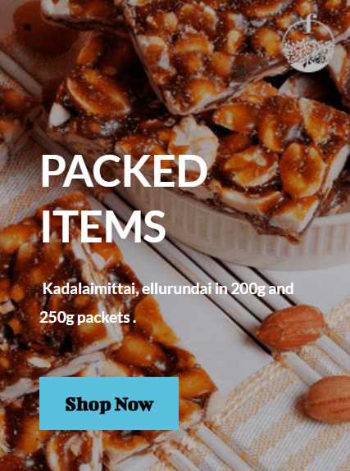

BAR ITEMS:

* 10, 12, 30 piece of kadalai mittai bar
* 10, 12, 30 piece of koko mittai bar

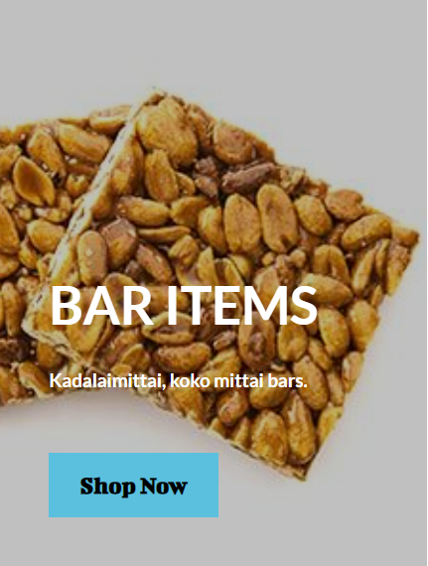

URUNDAI MITTAI:

* Kadalai urundai
* Ellu urundai



**ICON SECTION:**

* Best quality
* All over India
* Best offers
* Secured payment

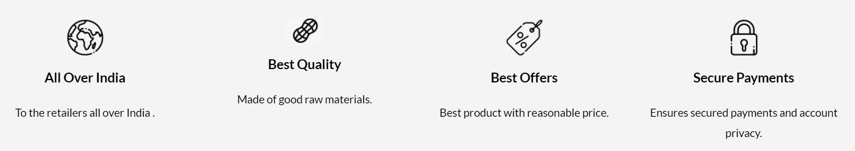

**BUTTON:**

* **Shop Button**

It will take the customer directly to the store page.



**STORE PAGE:**

This page consists of list of items in a mixed manner. Here, user can select the products accordingly.

**Search Button:**

Ithelps the customer to search the products.



**Combo Box:**

In this customer can sort the items according to their popularity, average rating, latest, by price(low to high and high to low),



**Browse by categories:**

Using this customer can select the products according to their categories.

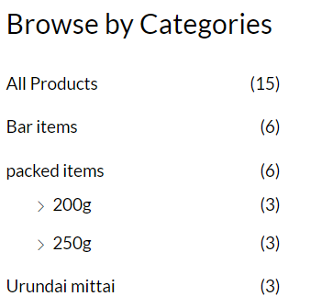

**Filter by price:**

If need customer can filter the products according to theirprice.

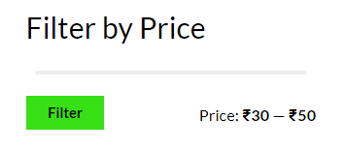

**Best sellers:**

Customer can view the top rated products in this section.

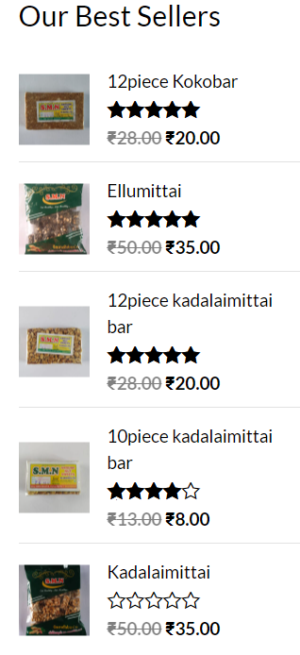

**ABOUT PAGE: Who we are?**



**CONTACT PAGE:**

In this cutomers comes to know about the email id, address, phone number of the shop. By using the map customer can find the shop location. They can zoom in and zoom out the map if needed.

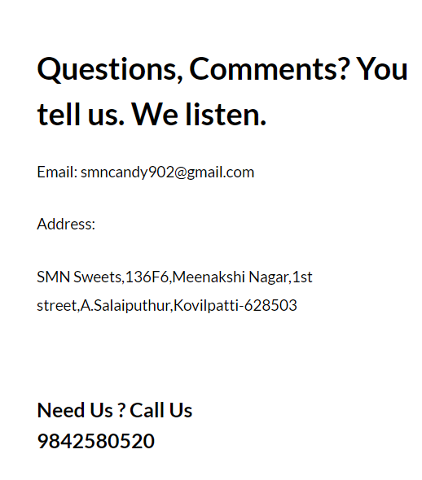

**WHATS APP :**

Customer can contact the shop by clicking the whats app icon available at the bottom of the page.



**PURCHASING OF PRODUCTS:**

* When customer chooses a product it leads to next page where they can view the details of the particular product.

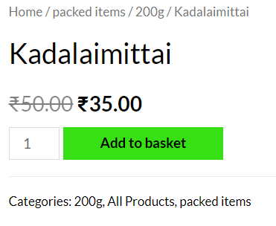

* They can also zoom in and zoom out the product image using the zoom icon present there.

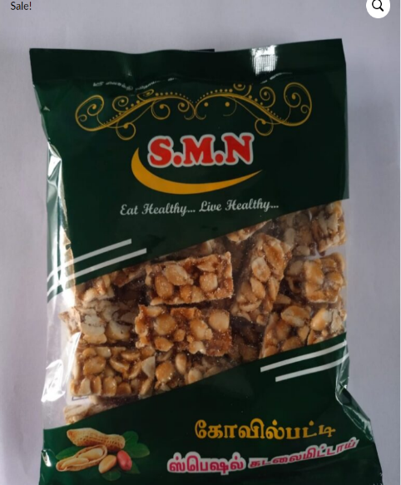 

* They can increase or decrease the quantity accordingly.



* Customer can also the give reviews to the products.

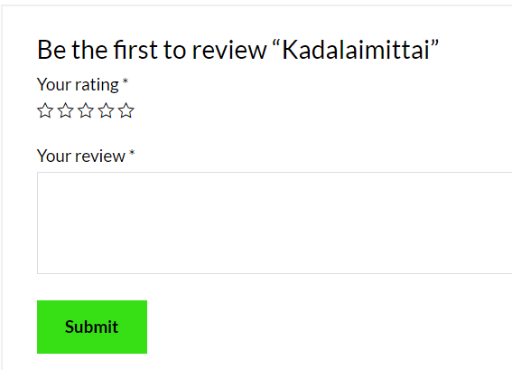

* Below the review section the related products will be shown.

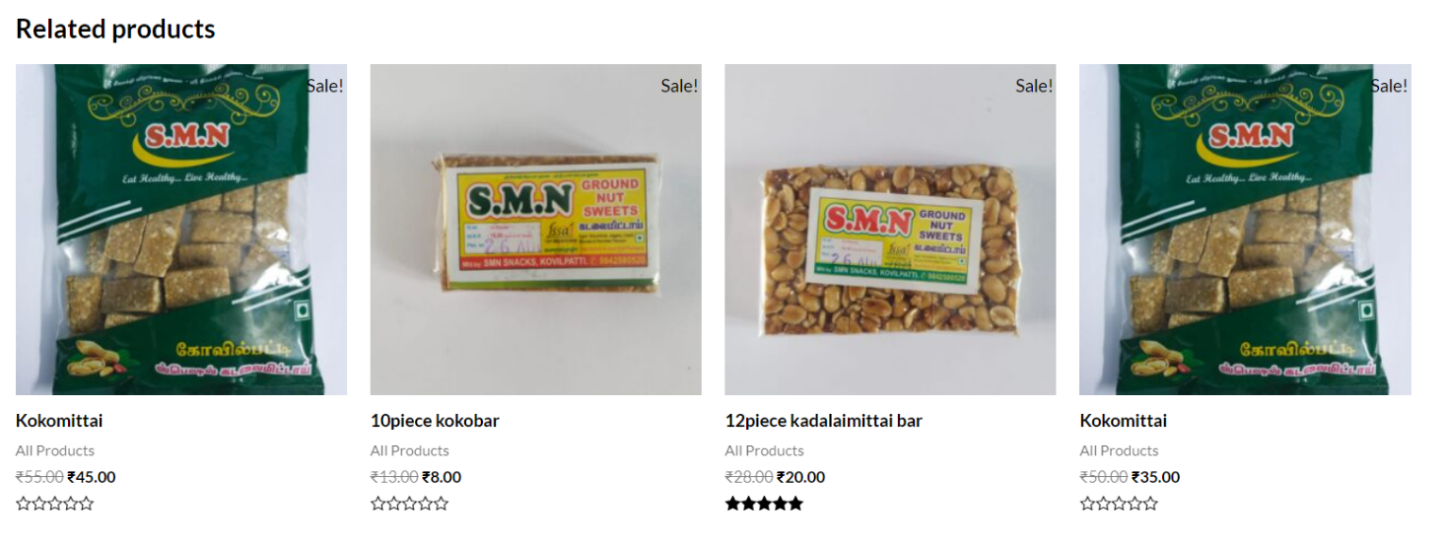

* Once the customer click the “Add to basket” button the product will be added to the basket and they can checkout by clicking “view basket” button.

Customer can add the products using the “Update basket” button.



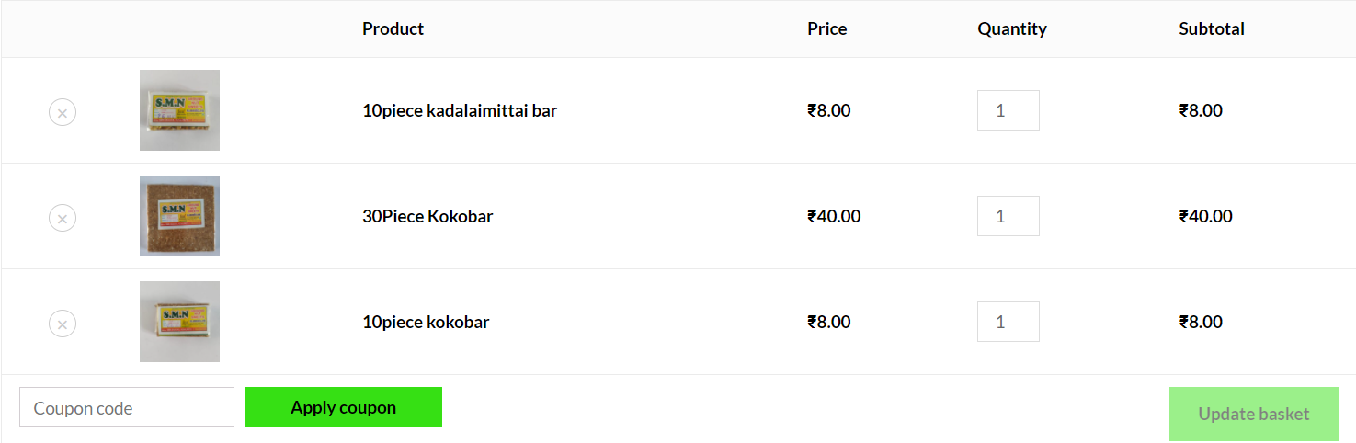

* Once they are done selecting the products they can proceed to the checkout page by clicking the” Proceed to checkout “ button.

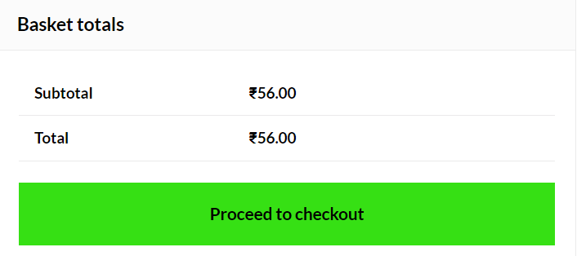

**IMAGE ZOOM OPT:**

Image zooming is special feature of our SMN CANDY ecommerce. If customer’s use this zooming tool on image



**CHECKOUT:**

In this page it will ask for the customer details which must be filled along the side they can view the checkout . Customer can place the order by clicking the “Place order” button.

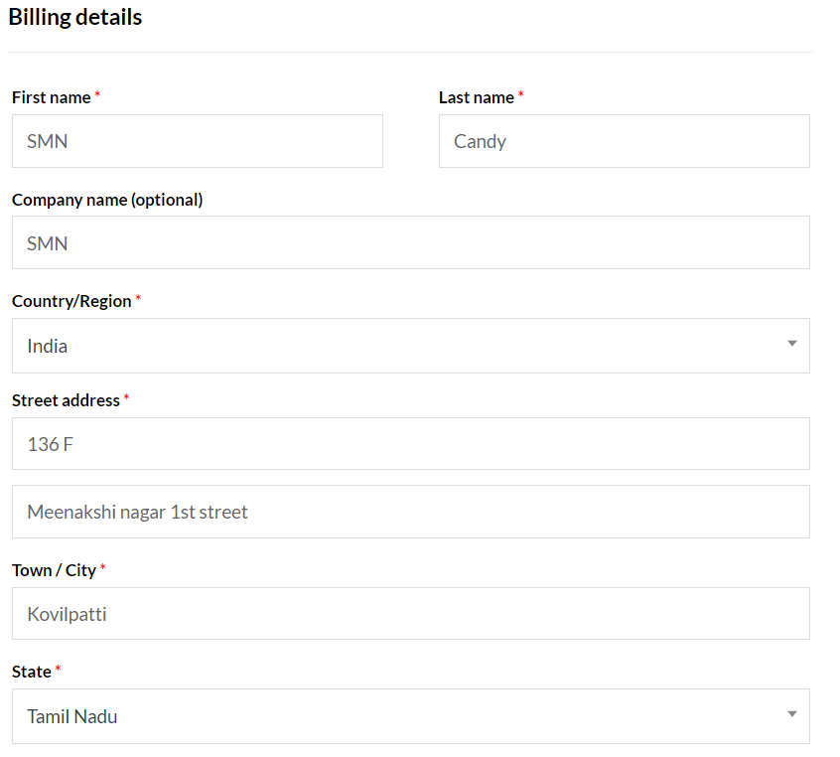

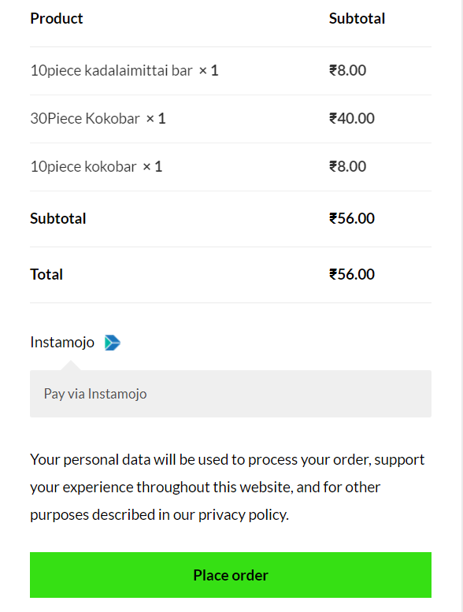

**PAYMENT MODE:**

Customer can pay through using the

* QR code



* UPI ID

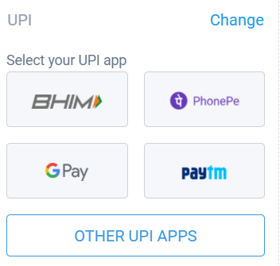

* More payment option,
* Customer can make the payment through credit card, debit card, net banking and wallets**.**

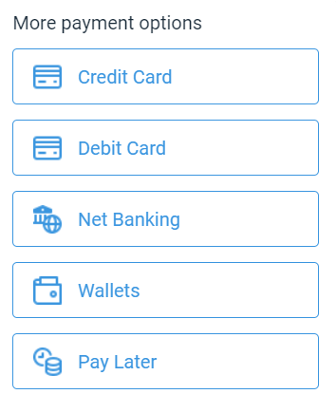

**INVOICE GENERATION:**

As soon as they made the payment it will send an invoice to the customer’s mail id. They can use it for further security purpose.

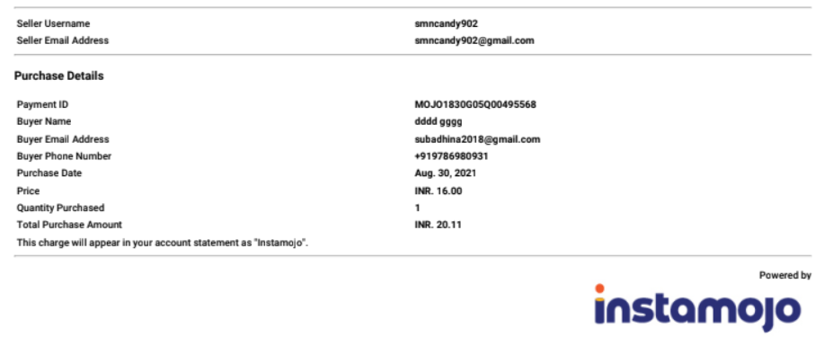

**PLUGINS USED:**

* **Starter template**
* Starter Templates is all in one solution for complete starter sites, single page templates, blocks & images. This plugin offers the premium library of ready templates & provides quick access to beautiful Pixabay images that can be imported in your website easily.
* **Woo commerce**
* An eCommerce toolkit that helps you sell anything. Beautifully.
* **Woo commerce Cart Abandonment Recovery**
* Recover your lost revenue. Capture email address of users on the checkout page and send follow up emails if they don't complete the purchase.
* **WooCommerce PDF Invoices & Packing Slips**
* Create, print & email PDF invoices & packing slips for WooCommerce orders.
* **WP Reset**
* Reset the entire site or just selected parts while reserving the option to undo by using snapshots.
* **WPForms Lite**
* Beginner friendly WordPress contact form plugin. Use our Drag & Drop form builder to create your WordPress forms.
* **Ninja Forms**
* Ninja Forms is a webform builder with unparalleled ease of use and features.
* **Instamojo for WooCommerce**
* Instamojo Payment Gateway for WooCommerce. Instamojo lets you collect payments instantly.
* **Elementor**
* The Elementor Website Builder has it all: drag and drop page builder, pixel perfect design, mobile responsive editing, and more.
* **Click to Chat**
* Let’s make your Web page visitors contact you through WhatsApp with a single click/tap.
* **CartFlows**
* Create beautiful checkout pages & sales flows for WooCommerce.

**CONCLUSION:**

The internet has become a major resource in modern business. The electronic shopping has gained significance not only from the entrepreneur’s but also from the customer’s point of view. For the entrepreneur, electronic shopping generates new business opportunities and for the customer, it makes comparative shopping generates new business opportunities and for the customer, it makes comparative shopping possible.

We have designed the project to provide the customer with easy navigation, retrieval of data and necessary feedback as much as possible. In this project, the user is provided with an e-commerce website that can be used to buy all types of peanut chikki products online.